What is logistic regression

Logistic regression is a statistical model used to analyze and predict binary outcomes. It’s commonly used in finance, marketing, healthcare, and social sciences to model and predict binary outcomes. A logistic regression model uses a logistic function to model the probability of a binary response variable,

Key Points:
- Logistic regression predicts the output of a categorical dependent variable. Therefore, the outcome must be a categorical or discrete value.
- It can be either Yes or No, 0 or 1, true or False, etc. but instead of giving the exact value as 0 and 1, it gives the probabilistic values which lie between 0 and 1.
- In Logistic regression, instead of fitting a regression line, we fit an “S” shaped logistic function, which predicts two maximum values (0 or 1).
- Logistic regression is one of the most popular Machine Learning algorithms, which comes under the Supervised Learning technique. It is used for predicting the categorical dependent variable using a given set of independent variables.
- Logistic Regression is much similar to the Linear Regression except that how they are used. Linear Regression is used for solving Regression problems, whereas Logistic regression is used for solving the classification problems.
- The curve from the logistic function indicates the likelihood of something such as whether the cells are cancerous or not, a mouse is obese or not based on its weight, etc.
- Logistic Regression is a significant machine learning algorithm because it has the ability to provide probabilities and classify new data using continuous and discrete datasets.
- Logistic Regression can be used to classify the observations using different types of data and can easily determine the most effective variables used for the classification.

What is Logistic Regression Model?
Logistic regression estimates the relationship between a dependent variable and one or more independent variables and predicts a categorical variable versus a continuous one. Here are a few things to know about logistic regression:
- Logistic regression is a Machine Learning method used for classification tasks.
- It is a predictive analytic technique based on the probability idea.
- The dependent variable in logistic regression is binary (coded as 1 or 0).
- The goal is to discover a link between characteristics and the likelihood of a specific outcome.
- Logistic regression uses a more sophisticated cost function called the “Sigmoid function” or “logistic function” instead of a linear function.
- The logistic regression hypothesis limits the cost function to a value between 0 and 1, making linear functions unsuitable for this task.
- Logistic regression is used in many fields, such as finance, marketing, healthcare, and social sciences, to model and predict binary outcomes.
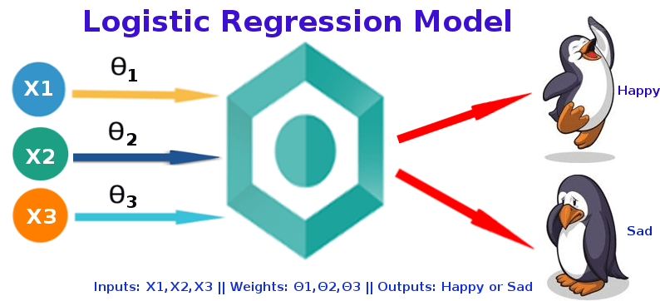
Logistic Regression is considered a regression model also. This model creates a regression model to predict the likelihood that a given data entry belongs to the category labeled “1.” Logistic regression models the data using the sigmoid function, much as linear regression assumes that the data follows a linear distribution.

Why the Name Logistic Regression?
It’s called ‘Logistic Regression’ since the technique behind it is quite similar to Linear Regression. The name “Logistic” comes from the Logit function, which is utilized in this categorization approach.

Why Can’t we use Linear Regression Instead of Logistic Regression?
The Differences between Linear Regression and Logistic Regression. Linear Regression is used to handle regression problems whereas Logistic regression is used to handle the classification problems. Linear regression provides a continuous output but Logistic regression provides discreet output.
Before answering this question, we will explain from Linear Regression concept, from the scratch then only we can understand it better. Although logistic regression is a sibling of linear regression, it is a classification technique, despite its name. Mathematically linear regression can be explained by,
- y = mx + c
- y – predicted value
- m – slope of the line
- x – input data
- c- Y-intercept or slope
We can forecast y values such as using these values. Now observe the below diagram for a better understanding
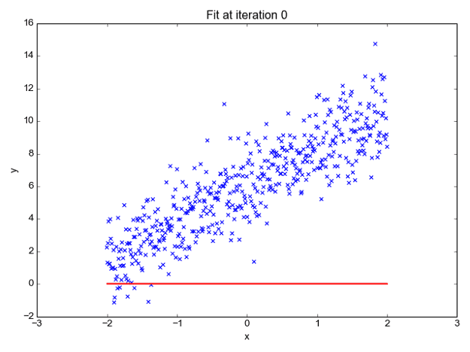
The x values are represented by the blue dots (the input data). We can now compute slope and y coordinate using the input data to ensure that our projected line (red line) covers most of the locations. We can now forecast any value of y given its x values using this line.
One thing to keep in mind about linear regression is that it only works with continuous data. If we want to include linear regression in our classification methods, we’ll have to adjust our algorithm a little more. First, we must choose a threshold so that if our projected value is less than the threshold, it belongs to class 1; otherwise, it belongs to class 2.
Now, if you’re thinking, “Oh, that’s simple, just create linear regression with a threshold, and hurray!, classification method,” there’s a catch. We must specify the threshold value manually, and calculating the threshold for huge datasets will be impossible. Furthermore, even if our anticipated values vary, the threshold value will remain the same. A logistic regression, on the other hand, yields a logistic curve with values confined to 0 and 1. The curve in logistic regression is generated using the natural logarithm of the target variable’s “odds,” rather than the probability, as in linear regression. Furthermore, the predictors need not be regularly distributed or have the same variance in each group.

And Now the Question?
This famous title question was explained by our beloved person Andrew Ng, assume we have information about tumor size and malignancy. Because this is a classification issue, we can see that all the values will fall between 0 and 1. And, by fitting the best-found regression line and assuming a threshold of 0.5, we can do a very good job with the line.
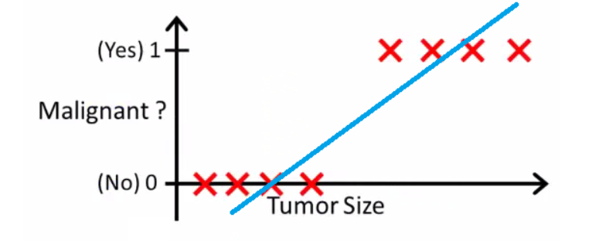
We can choose a point on the x-axis from which all values on the left side are regarded as negative, and all values on the right side are considered positive.
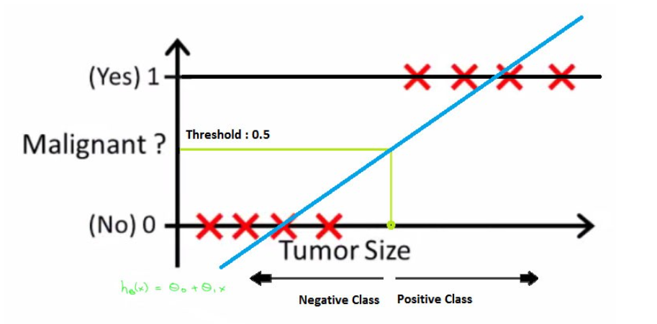
But what if the data contains an outlier? Things would become shambles. For 0.5 thresholds, for example,
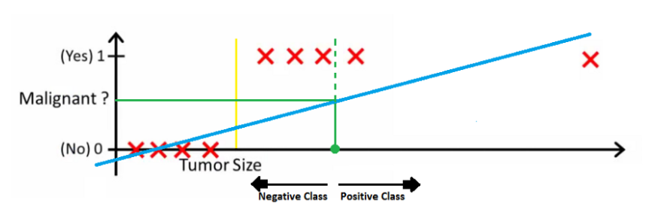
Even if we fit the best-found regression line, we won’t be able to determine any point where we can distinguish classes. It will insert some instances from the positive class into the negative class. The green dotted line (Decision Boundary) separates malignant and benign tumors; however, it should have been a yellow line that clearly separates the positive and negative cases. As a result, even a single outlier can throw the linear regression estimates off. And it’s here that logistic regression comes into play.

Logistic Function – Sigmoid Function
- The sigmoid function is a mathematical function used to map the predicted values to probabilities.
- It maps any real value into another value within a range of 0 and 1. The value of the logistic regression must be between 0 and 1, which cannot go beyond this limit, so it forms a curve like the “S” form.
- The S-form curve is called the Sigmoid function or the logistic function.
- In logistic regression, we use the concept of the threshold value, which defines the probability of either 0 or 1. Such as values above the threshold value tends to 1, and a value below the threshold values tends to 0.

This is the Sigmoid function, which produces an S-shaped curve. It always returns a probability value between 0 and 1. The Sigmoid function is used to convert expected values to probabilities. The function converts any real number into a number between 0 and 1. We utilize sigmoid to translate predictions to probabilities in machine learning.
The mathematically sigmoid function can be,
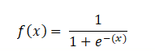
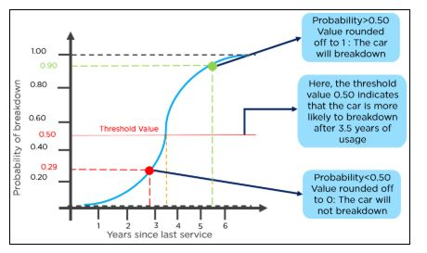

Types of Logistic Regression
In general, it can be classified into,
- Binary Logistic Regression – two or binary outcomes like yes or no
- Multinomial Logistic Regression – three or more outcomes like first, second, and third class or no class degree
- Ordinal Logistic Regression – three or more like multinomial logistic regression but here with the order like customer rating in the supermarket from 1 to 5

Assumptions of Logistic Regression
We will explore the assumptions of logistic regression as understanding these assumptions is important to ensure that we are using appropriate application of the model. The assumption include:
- Independent observations: Each observation is independent of the other. meaning there is no correlation between any input variables.
- Binary dependent variables: It takes the assumption that the dependent variable must be binary or dichotomous, meaning it can take only two values. For more than two categories SoftMax functions are used.
- Linearity relationship between independent variables and log odds: The relationship between the independent variables and the log odds of the dependent variable should be linear.
- No outliers: There should be no outliers in the dataset.
- Large sample size: The sample size is sufficiently large

Terminologies involved in Logistic Regression
Here are some common terms involved in logistic regression:
- Independent variables: The input characteristics or predictor factors applied to the dependent variable’s predictions.
- Dependent variable: The target variable in a logistic regression model, which we are trying to predict.
- Logistic function: The formula used to represent how the independent and dependent variables relate to one another. The logistic function transforms the input variables into a probability value between 0 and 1, which represents the likelihood of the dependent variable being 1 or 0.
- Odds: It is the ratio of something occurring to something not occurring. it is different from probability as the probability is the ratio of something occurring to everything that could possibly occur.
- Log-odds: The log-odds, also known as the logit function, is the natural logarithm of the odds. In logistic regression, the log odds of the dependent variable are modeled as a linear combination of the independent variables and the intercept.
- Coefficient: The logistic regression model’s estimated parameters, show how the independent and dependent variables relate to one another.
- Intercept: A constant term in the logistic regression model, which represents the log odds when all independent variables are equal to zero.
- Maximum likelihood estimation: The method used to estimate the coefficients of the logistic regression model, which maximizes the likelihood of observing the data given the model.

Why can’t the cost function that was used for linearity be used for logistics?
The cost function for linear regression is mean squared error. If this is utilized for logistic regression, the function of parameters will be non-convex. Only if the function is convex will gradient descent lead to a global minimum.

Cost function – Linear Regression Vs Logistic Regression
Linear regression employs the Least Squared Error as the loss function, which results in a convex network, which we can then optimize by identifying the vertex as the global minimum. For logistic regression, however, it is no longer a possibility. Because the hypothesis has been modified, calculating Least Squared Error using the sigmoid function on raw model output will result in a non-convex graph with local minimums.
What is cost function? Cost functions are used in machine learning to estimate how poorly models perform. Simply put, a cost function is a measure of how inaccurate the model is in estimating the connection between X and y. This is usually stated as a difference or separation between the expected and actual values. A machine learning model’s goal is to discover parameters, weights, or a structure that minimizes the cost function.
A convex function indicates there will be no intersection between any two points on the curve, but a non-convex function will have at least one intersection. In terms of cost functions, a convex type always guarantees a global minimum, whereas a non-convex type only guarantees local minima.
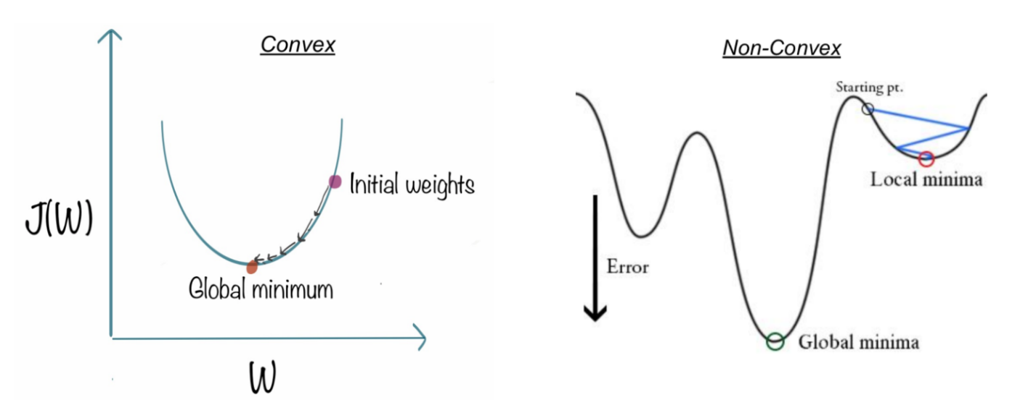

How to Reduce Cost Function? – Gradient Descent
The challenge now is: how can we lower the cost value? Gradient Descent can be used to accomplish this. Gradient descent’s main objective is to reduce the cost value.
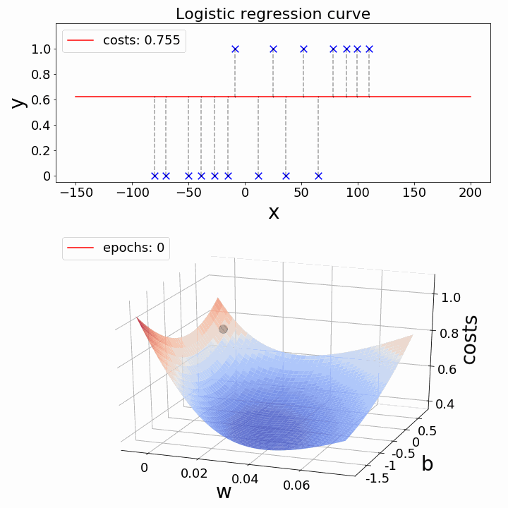

Regularization
Let’s also discuss Regularization quickly for reducing the cost function to match the parameters to training data. L1 (Lasso) and L2 (Lasso) are the two most frequent regularization types (Ridge). Instead of simply maximizing the aforementioned cost function, regularization imposes a limit on the size of the coefficients in order to avoid overfitting. L1 and L2 use distinct approaches to defining upper limits for coefficients, allowing L1 to conduct feature selection by setting coefficients to 0 for less relevant characteristics and reducing multi-collinearity, whereas L2 penalizes extremely large coefficients but does not set any to 0. There’s also a parameter that regulates the constraint’s weight, λ, to ensure that coefficients aren’t penalized too harshly, resulting in underfitting.
It’s a fascinating topic to investigate why L1 and L2 have different capacities owing to the ‘squared’ and ‘absolute’ values, and how λ affects the weight of regularized and original fit terms. We won’t go into everything here, but it’s well worth your time and effort to learn about. The steps below demonstrate how to convert an original cost function to a regularized cost function.

How Logistic Regression links with Neural Network?
We all know that Neural Networks are the foundation for Deep Learning. The best part is that Logistic Regression is intimately linked to Neural networks. Each neuron in the network may be thought of as a Logistic Regression; it contains input, weights, and bias, and you conduct a dot product on all of that before applying any non-linear function. Furthermore, a neural network’s last layer is a basic linear model (most of the time). That can be understood by visualization as shown below,
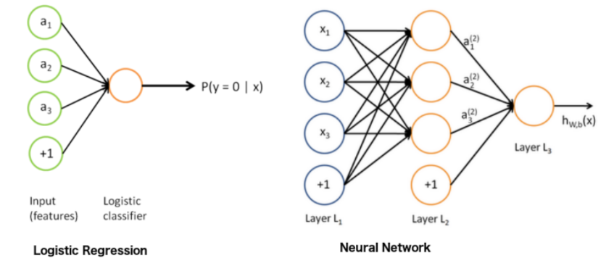
Take a deeper look at the “output layer,” and you’ll notice that it’s a basic linear (or logistic) regression: we have the input (hidden layer 2), the weights, a dot product, and finally a non-linear function, depends on the task. A helpful approach to thinking about neural networks is to divide them into two parts: representation and classification/regression. The first section (on the left) aims to develop a decent data representation that will aid the second section (on the right) is doing a linear classification/regression.
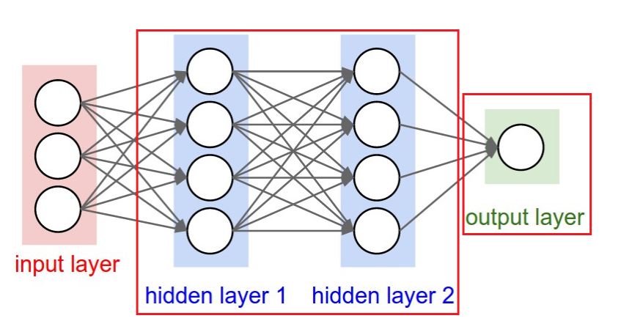

How to Evaluate Logistic Regression Model?
We can evaluate the logistic regression model using the following metrics:
- Accuracy: Accuracy provides the proportion of correctly classified instances.
𝐴𝑐𝑐𝑢𝑟𝑎𝑐𝑦=𝑇𝑟𝑢𝑒𝑃𝑜𝑠𝑖𝑡𝑖𝑣𝑒𝑠+𝑇𝑟𝑢𝑒𝑁𝑒𝑔𝑎𝑡𝑖𝑣𝑒𝑠 / 𝑇𝑜𝑡𝑎𝑙​
- Precision: Precision focuses on the accuracy of positive predictions.
𝑃𝑟𝑒𝑐𝑖𝑠𝑖𝑜𝑛=𝑇𝑟𝑢𝑒𝑃𝑜𝑠𝑖𝑡𝑖𝑣𝑒𝑠 / 𝑇𝑟𝑢𝑒𝑃𝑜𝑠𝑖𝑡𝑖𝑣𝑒𝑠+𝐹𝑎𝑙𝑠𝑒𝑃𝑜𝑠𝑖𝑡𝑖𝑣𝑒𝑠​
- Recall (Sensitivity or True Positive Rate): Recall measures the proportion of correctly predicted positive instances among all actual positive instances.
𝑅𝑒𝑐𝑎𝑙𝑙=𝑇𝑟𝑢𝑒𝑃𝑜𝑠𝑖𝑡𝑖𝑣𝑒𝑠 / 𝑇𝑟𝑢𝑒𝑃𝑜𝑠𝑖𝑡𝑖𝑣𝑒𝑠+𝐹𝑎𝑙𝑠𝑒𝑁𝑒𝑔𝑎𝑡𝑖𝑣𝑒𝑠​
- F1 Score: F1 score is the harmonic mean of precision and recall.
𝐹1𝑆𝑐𝑜𝑟𝑒=2∗𝑃𝑟𝑒𝑐𝑖𝑠𝑖𝑜𝑛∗𝑅𝑒𝑐𝑎𝑙𝑙/ 𝑃𝑟𝑒𝑐𝑖𝑠𝑖𝑜𝑛+𝑅𝑒𝑐𝑎𝑙𝑙​
- Area Under the Receiver Operating Characteristic Curve (AUC-ROC): The ROC curve plots the true positive rate against the false positive rate at various thresholds. AUC-ROC measures the area under this curve, providing an aggregate measure of a model’s performance across different classification thresholds.
- Area Under the Precision-Recall Curve (AUC-PR): Similar to AUC-ROC, AUC-PR measures the area under the precision-recall curve, providing a summary of a model’s performance across different precision-recall trade-offs.

Precision-Recall Tradeoff in Logistic Regression Threshold Setting
Logistic regression becomes a classification technique only when a decision threshold is brought into the picture. The setting of the threshold value is a very important aspect of Logistic regression and is dependent on the classification problem itself.
The decision for the value of the threshold value is majorly affected by the values of precision and recall. Ideally, we want both precision and recall being 1, but this seldom is the case.
In the case of a Precision-Recall tradeoff, we use the following arguments to decide upon the threshold:
- Low Precision/High Recall: In applications where we want to reduce the number of false negatives without necessarily reducing the number of false positives, we choose a decision value that has a low value of Precision or a high value of Recall. For example, in a cancer diagnosis application, we do not want any affected patient to be classified as not affected without giving much heed to if the patient is being wrongfully diagnosed with cancer. This is because the absence of cancer can be detected by further medical diseases, but the presence of the disease cannot be detected in an already rejected candidate.
- High Precision/Low Recall: In applications where we want to reduce the number of false positives without necessarily reducing the number of false negatives, we choose a decision value that has a high value of Precision or a low value of Recall. For example, if we are classifying customers whether they will react positively or negatively to a personalized advertisement, we want to be absolutely sure that the customer will react positively to the advertisement because otherwise, a negative reaction can cause a loss of potential sales from the customer.

Differences Between Linear and Logistic Regression
The difference between linear regression and logistic regression is that linear regression output is the continuous value that can be anything while logistic regression predicts the probability that an instance belongs to a given class or not.
Linear Regression | Logistic Regression
Linear regression is used to predict the continuous dependent variable using a given set of independent variables. | Logistic regression is used to predict the categorical dependent variable using a given set of independent variables.
Linear regression is used for solving regression problem. | It is used for solving classification problems.
In this we predict the value of continuous variables | In this we predict values of categorical variables
In this we find best fit line. | In this we find S-Curve.
Least square estimation method is used for estimation of accuracy. | Maximum likelihood estimation method is used for Estimation of accuracy.
The output must be continuous value, such as price, age, etc. | Output must be categorical value such as 0 or 1, Yes or no, etc.
It required linear relationship between dependent and independent variables. | It not required linear relationship.
There may be collinearity between the independent variables. | There should be little to no collinearity between independent variables.

Hyperparameter Fine-tuning – Logistic Regression
There are no essential hyperparameters to adjust in logistic regression. Even though it has many parameters, the following three parameters might be helpful in fine-tuning for some better results,
Regularization (penalty) might be beneficial at times.
Penalty – {‘l1’, ‘l2’, ‘elasticnet’, ‘none’}, default=’l2’
The penalty strength is controlled by the C parameter, which might be useful.
C – float, default=1.0
With different solvers, you might sometimes observe useful variations in performance or convergence.
Solver – {‘newton-cg’, ‘lbfgs’, ‘liblinear’, ‘sag’, ‘saga’}, default=’lbfgs’
Note: The algorithm to use is determined by the penalty: Solver-supported penalties:
- ‘newton-cg’ – [‘l2’, ‘none’]
- ‘lbfgs’ – [‘l2’, ‘none’]
- ‘liblinear’ – [‘l1’, ‘l2’]
- ‘sag’ – [‘l2’, ‘none’]
- ‘saga’ – [‘elasticnet’, ‘l1’, ‘l2’, ‘none’]

Advantages of Logistic Regression
- Overfitting is less likely with logistic regression, although it can happen in high-dimensional datasets. In these circumstances, regularization (L1 and L2) techniques may be used to minimize over-fitting.
- It works well when the dataset is linearly separable and has good accuracy for many basic data sets.
- It is more straightforward to apply, understand, and train.
- The inferences regarding the relevance of each characteristic are based on the anticipated parameters (trained weights). The association’s orientation, positive or negative, is also specified. As a result, logistic regression may be used to determine the connection between the characteristics.
- Unlike decision trees or support vector machines, this technique allows models to be readily changed to incorporate new data. Stochastic gradient descent can be used to update the data.
- It is less prone to over-fitting in a low-dimensional dataset with enough training instances.
- When the dataset includes linearly separable characteristics, Logistic Regression shows to be highly efficient.
- It has a strong resemblance to neural networks. A neural network representation may be thought of as a collection of small logistic regression classifiers stacked together.
- The training time of the logistic regression method is considerably smaller than that of most sophisticated algorithms, such as an Artificial Neural Network, due to its simple probabilistic interpretation.
- Multinomial Logistic Regression is the name given to an approach that may easily be expanded to multi-class classification using a softmax classifier.

Disadvantages of Logistic Regression
- Logistic Regression should not be used if the number of observations is fewer than the number of features; otherwise, it may result in overfitting.
- Because it creates linear boundaries, we won’t obtain better results when dealing with complex or non-linear data.
- It’s only good for predicting discrete functions. As a result, the Logistic Regression dependent variable is restricted to the discrete number set.
- The average or no multicollinearity between independent variables is required for logistic regression.
- Logistic regression needs a big dataset and enough training samples to identify all of the categories.
- Because this method is sensitive to outliers, the presence of data values in the dataset that differs from the anticipated range may cause erroneous results.
- Only significant and relevant features should be utilized to construct a model; otherwise, the model’s probabilistic predictions may be inaccurate, and its predictive value may suffer.
- Complex connections are difficult to represent with logistic regression. This technique is readily outperformed by more powerful and sophisticated algorithms such as Neural Networks.
- Because logistic regression has a linear decision surface, it cannot address nonlinear issues. In real-world settings, linearly separable data is uncommon. As a result, non-linear features must be transformed, which may be done by increasing the number of features such that the data can be separated linearly in higher dimensions.
- Based on independent variables, a statistical analysis model seeks to predict accurate probability outcomes. On high-dimensional datasets, this may cause the model to be over-fit on the training set, overstating the accuracy of predictions on the training set, and so preventing the model from accurately predicting outcomes on the test set. This is most common when the model is trained on a little amount of training data with many features. Regularization strategies should be explored on high-dimensional datasets to minimize over-fitting (but this makes the model complex). The model may be under-fit on the training data if the regularization parameters are too high.

Application of Logistic Regression
All use cases where data must be categorized into multiple groups are covered by Logistic Regression. Consider the following illustration:
- Fraud detection in Credit card
- Email spam or ham
- Sentiment Analysis in Twitter analysis
- Image segmentation, recognition, and classification – X-rays, Scans
- Object detection through video
- Handwriting recognition
- Disease prediction – Diabetes, Cancer, Parkinson etc.

